This document describes the understanding of Swagger with Spring Boot.
Let’s talk about the problem: We have an API that we want to document. Specifically, a REST API.
We can maintain a document with that information or an HTML website, or even have it generated by some tool from our code. The downside to this approach is that we need to keep it maintained manually (or via a semi-automatic process) and, while it is human-readable, it’s not really machine-readable.
Another approach is to use WADL, which can be generated by some tools. In this case, it’s machine-readable, but definitely not human-readable. Also, writing a WADL manually is a tedious process.
Seeking out a simpler solution for both made Swagger come to life. Swagger is a set of rules (in other words, a specification) for a format describing REST APIs. The format is both machine-readable and human-readable. As a result, it can be used to share documentation among product managers, testers and developers, but can also be used by various tools to automate API-related processes.

Swagger is an Interface Description Language for describing RESTful APIs expressed using JSON. Swagger is used together with a set of open-source software tools to design, build, document, and use RESTful web services. Swagger includes automated documentation, code generation, and test-case generation.

Example 1:

Create a spring boot app using: https://start.spring.io/

Select Maven project, Java in language & 2.6.2 in spring boot.

In project metadata:
Group: springBootApp.examples
Artifact: firstSpringBootSwaggerApp1
Name: firstSpringBootSwaggerApp1
package: springBootApp.examples.firstSpringBootSwaggerApp1

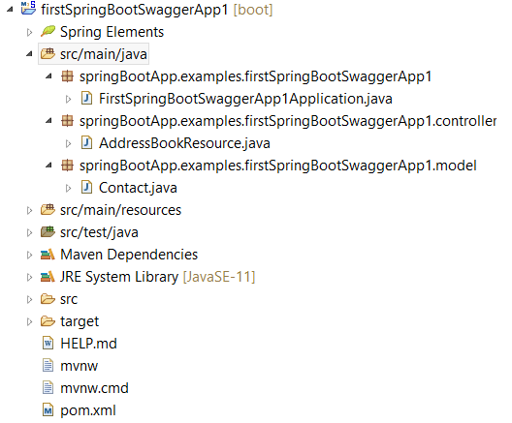
POM.xml
<dependencies>
<dependency>
<groupId>io.springfox</groupId>
<artifactId>springfox-boot-starter</artifactId>
<version>3.0.0</version>
</dependency>

<dependency>
<groupId>org.springframework.boot</groupId>
<artifactId>spring-boot-starter-web</artifactId>
</dependency>

<dependency>
<groupId>org.springframework.boot</groupId>
<artifactId>spring-boot-starter-test</artifactId>
<scope>test</scope>
</dependency>
</dependencies>
Contact.java
package springBootApp.examples.firstSpringBootSwaggerApp1.model;
public class Contact {
private String id;
private String name;
private String phone;
public String getId() {
return id;
}
public void setId(String id) {
this.id = id;
}
public String getName() {
return name;
}
public void setName(String name) {
this.name = name;
}
public String getPhone() {
return phone;
}
public void setPhone(String phone) {
this.phone = phone;
}
@Override
public String toString() {
return "Contact [id=" + id + ", name=" + name + ", phone=" + phone + "]";
}
}
AddressBookResource.java
package springBootApp.examples.firstSpringBootSwaggerApp1.controller;
import java.util.ArrayList;
import java.util.List;
import java.util.concurrent.ConcurrentHashMap;
import java.util.concurrent.ConcurrentMap;
import org.springframework.web.bind.annotation.GetMapping;
import org.springframework.web.bind.annotation.PathVariable;
import org.springframework.web.bind.annotation.PostMapping;
import org.springframework.web.bind.annotation.RequestBody;
import org.springframework.web.bind.annotation.RestController;
import springBootApp.examples.firstSpringBootSwaggerApp1.model.Contact;
@RestController
public class AddressBookResource {
ConcurrentMap<String, Contact> contacts = new ConcurrentHashMap<>();
Contact contact;
AddressBookResource() {
contact = new Contact();
contact.setId("101");
contact.setName("Mohan");
contact.setPhone("9988556688");
contacts.put(contact.getId(), contact);
}
@GetMapping(value = "/")
public List<Contact> getAllContact() {
return new ArrayList<Contact>(contacts.values());
}
@GetMapping(value = "/{id}")
public Contact getContact(@PathVariable String id) {
return contacts.get(id);
}
@PostMapping(value = "/")
public Contact addContact(@RequestBody Contact contact) {
contacts.put(contact.getId(), contact);
return contact;
}
}
FirstSpringBootSwaggerApp1Application.java
package springBootApp.examples.firstSpringBootSwaggerApp1;
import org.springframework.boot.SpringApplication;
import org.springframework.boot.autoconfigure.SpringBootApplication;
import org.springframework.web.servlet.config.annotation.EnableWebMvc;
import springfox.documentation.swagger2.annotations.EnableSwagger2;
@SpringBootApplication
@EnableSwagger2
@EnableWebMvc
public class FirstSpringBootSwaggerApp1Application {
public static void main(String[] args) {
SpringApplication.run(FirstSpringBootSwaggerApp1Application.class, args);
}
}
Run the application, request from postman as post request and type the following text in the bodyraw text area to add the record to the ArrayList of the contact:
[{
"id":101,
"name":"John",
"phone":"9988556644"
},
{
"id":"foo",
"name":"Mr. Foo",
"phone": "1234-1234-1234"
},

{
"id":"bar",
"name":"Mr. Bar",
"phone": "1234-1234-1234"
}]
Run the following url to see the Swagger Rest API documents:
http://localhost:8080/v3/api-docs
http://localhost:8080/swagger-ui/index.html
You can also use the following URL to create swagger app:
https://editor.swagger.io/

